## **Basic Project Plan**

#### **Purpose**

The purpose of this project is to visually show the differences between the magnitudes of earthquakes all over the world for the last seven days.

#### **Tasks**

To complete this project, use a URL for GeoJSON earthquake data from the USGS website and retrieve geographical coordinates and the magnitudes of earthquakes for the last seven days. Then add the data to a map.

#### **Approach**

Your approach will be to use the JavaScript and the D3.js library to retrieve the coordinates and magnitudes of the earthquakes from the GeoJSON data. You'll use the Leaflet library to plot the data on a Mapbox map through an API request and create interactivity for the earthquake data.

..set up a Mapbox account and get the API token you'll need to create geographical maps.

13.2.1**The Mapbox API**

Mapbox provides custom maps for websites and applications such as Strava, Facebook, the *Financial Times*, The Weather Channel, Snapchat, and Instacart. Since October 2019, Mapbox has been generating up to 14 billion individual sensor readings daily across 100,000 map updates on connected devices.

<https://account.mapbox.com/>

13.2.2 **Create a Branch on Your Repository**

Branching makes it possible to create an isolated environment when creating a new feature, or to correct an issue in the main code no matter the scope.

Follow these steps to create a branch:

1. Navigate to the repository folder on your computer.
2. In Terminal on macOS or Git Bash on Windows, type git pull or git pull origin main and press Enter.
3. Type git checkout -b Simple_Leaflet_Map and press Enter.
   * git checkout lets us navigate between branches.
   * -b indicates we are creating a new branch.
   * The name of the new branch follows -b.

After pressing Enter, your terminal should return the following: Switched to a new branch 'Simple_Leaflet_Map'

Now we are in the Simple_Leaflet_Map branch. Confirm this by typing git branch and pressing Enter.

At this point, the folder structure on your computer hasn't changed. The files you had in your main branch are now in your Simple_Leaflet_Map branch. Visually, the repository should look like the following 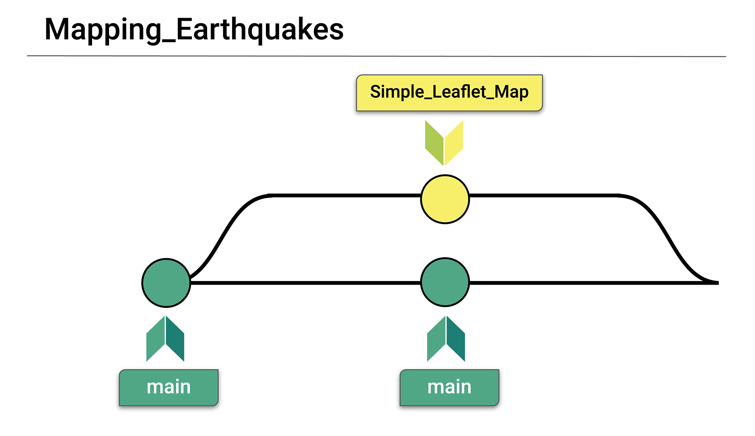

13.2.3 **Create an HTML File and CSS File**

create an HTML file and CSS file and add links to some stylesheets in the HTML file…Leaflet has a few links and simple HTML code that we will add to an index.html page.

## **The Leaflet JavaScript Library**

On the [Leaflet (Links to an external site.)](https://leafletjs.com/index.html)

homepage, scroll midpage and click the [Leaflet Quick Start Guide (Links to an external site.)](https://leafletjs.com/examples/quick-start/)

Link:

The Leaflet Quick Start Guide provides steps for setting up a Leaflet map. To begin, scroll midpage to the "Preparing your page" section:

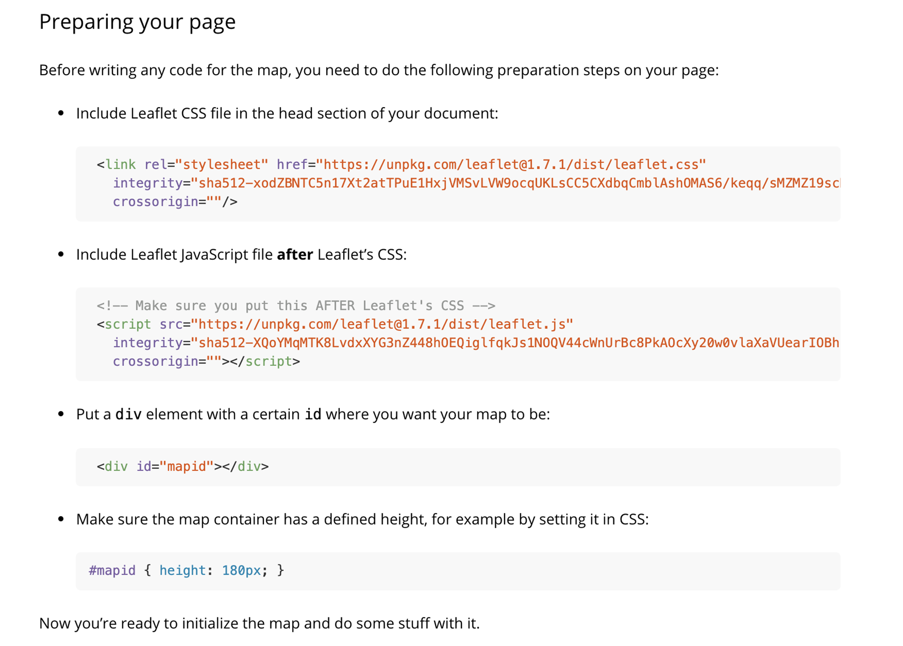

The "Preparing your page" section includes links and HTML code that we'll add to our index.html page. First, we'll create a folder structure for our earthquake map webpage.

## **Create an HTML Page**

Open your Mapping_Earthquakes repository folder in Visual Studio Code (VS Code). Create a new folder called "Simple_Map." Inside the folder, create a new index.html file. Next, create a template for your index.html file.

(To create a template for an html file, type an ! (exclamation point) and press Tab or Enter, and the empty file will be filled with the complete HTML5 boilerplate code.)

In our index.html file, we'll change the document title and add the code from the "Preparing your page" section

1. Change the document title in the <title> element in the <head> section (<title>Document</title>) to "Leaflet-Basic-Map."
2. In the <head> section, just below the <title> element, add the following Leaflet CSS script from the "Preparing your page" section:

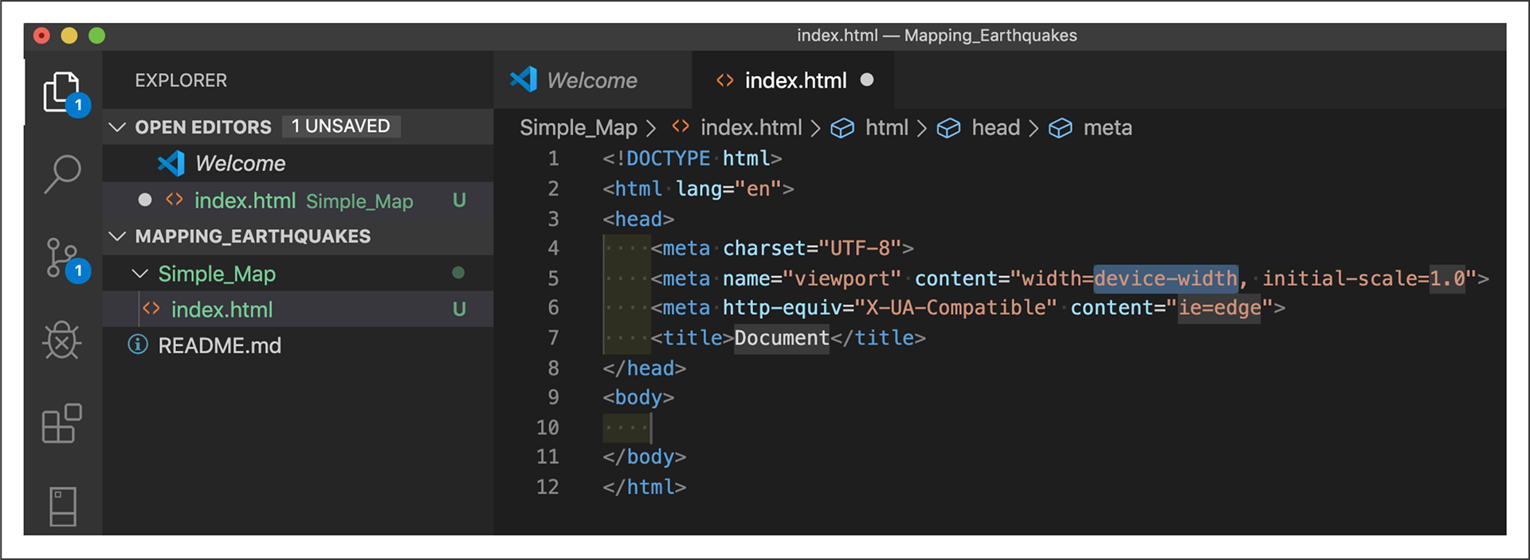

<!-- Leaflet CSS -->

<link rel="stylesheet" href="https://unpkg.com/leaflet@1.7.1/dist/leaflet.css"

integrity="sha512-xodZBNTC5n17Xt2atTPuE1HxjVMSvLVW9ocqUKLsCC5CXdbqCmblAshOMAS6/keqq/sMZMZ19scR4PsZChSR7A=="

crossorigin=""/>

3. In the body of our index.html file, add the Leaflet JavaScript script:

<!-- Leaflet JavaScript -->

<script src="https://unpkg.com/leaflet@1.7.1/dist/leaflet.js"

integrity="sha512-XQoYMqMTK8LvdxXYG3nZ448hOEQiglfqkJs1NOQV44cWnUrBc8PkAOcXy20w0vlaXaVUearIOBhiXZ5V3ynxwA=="

crossorigin=""></script>

The Leaflet CSS and JavaScript files we added to the index.html file are referred to as content delivery networks (CDNs). Using CDNs has a security risk. To avoid the security risk, it's a best practice to include an integrity value with the CDN. Each file we added has its own integrity value, which is a Base64-encoded cryptographic hash of a resource that prevents the CDN from being hacked

For more about the Subresource Integrity value, please see the documentation on the [Download Leaflet webpage](https://leafletjs.com/download.html)

[(Links to an external site.)](https://leafletjs.com/download.html)

and Mozilla Developers' [Subresource Integrity webpage (Links to an external site.)](https://developer.mozilla.org/en-US/docs/Web/Security/Subresource_Integrity)

4. Above the Leaflet JavaScript link script, add the following <div> element with the id tag for the map, as shown in the "Preparing your page" section:

<!-- The div that holds our map -->

<div id="mapid"></div>

After adding the Leaflet CSS file, JavaScript file, and the <div> element with theid tag for the map, our index.html file should look like the following:

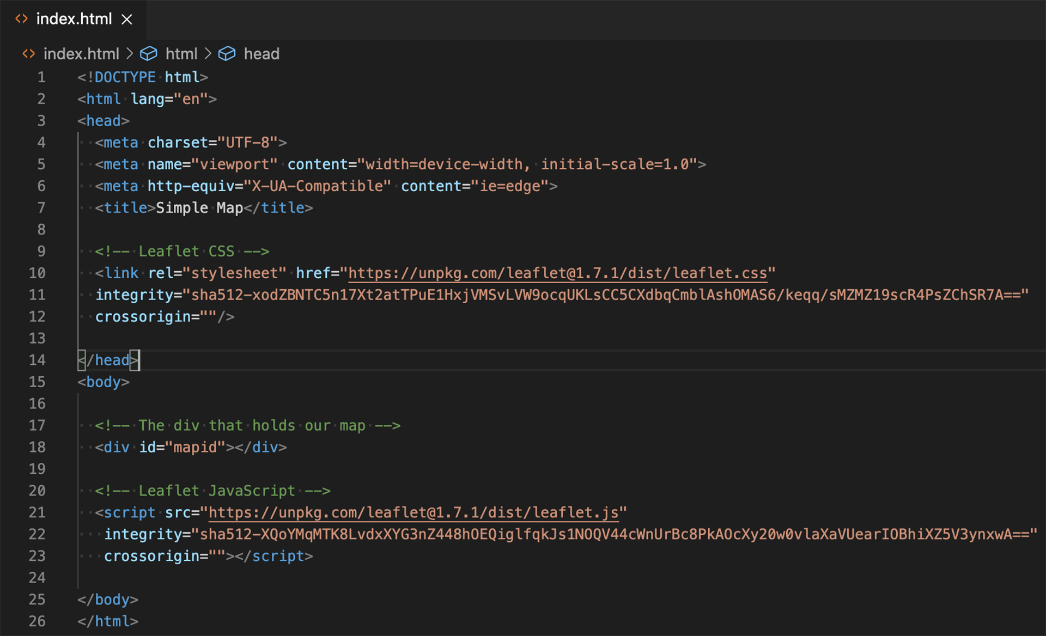

(Make sure you copy and paste the Leaflet CSS file and JavaScript script from the website as they appear. Do not edit the script by deleting empty spaces. This will prevent that script from working on the index.html file, resulting in the map not being shown on the webpage.)

**Next, we will modify our #mapid to be set at a specific height using CSS code. To do this, we'll need to create a style.css file.**

## **Create a CSS File**

***Before we create a style.css file, we'll need to create a folder for the file. In VS Code, create a new subfolder called "static" in our Simple_Map folder. In this folder, create another subfolder named "css." In the css folder, create a new file and name it style.css:

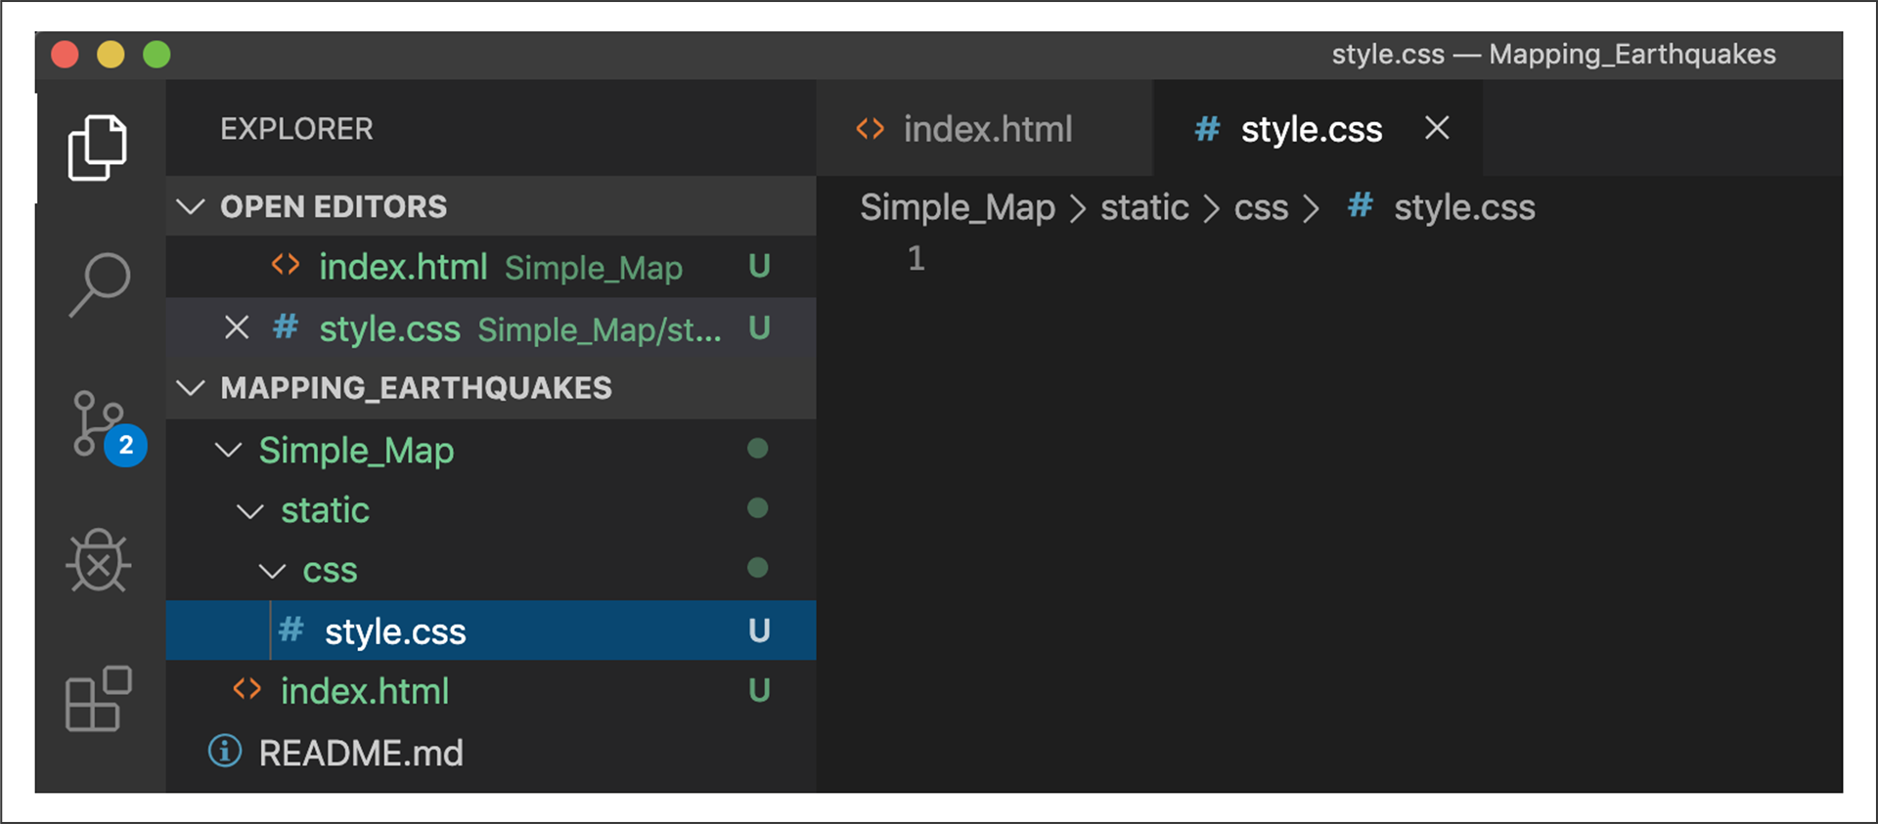

**Next**, add the following CSS code to our style.css file to set the style for our map on our index.html page and save the file:

html,

body,

#mapid {

width: 100%;

height: 100%;

padding: 0;

margin: 0;

}

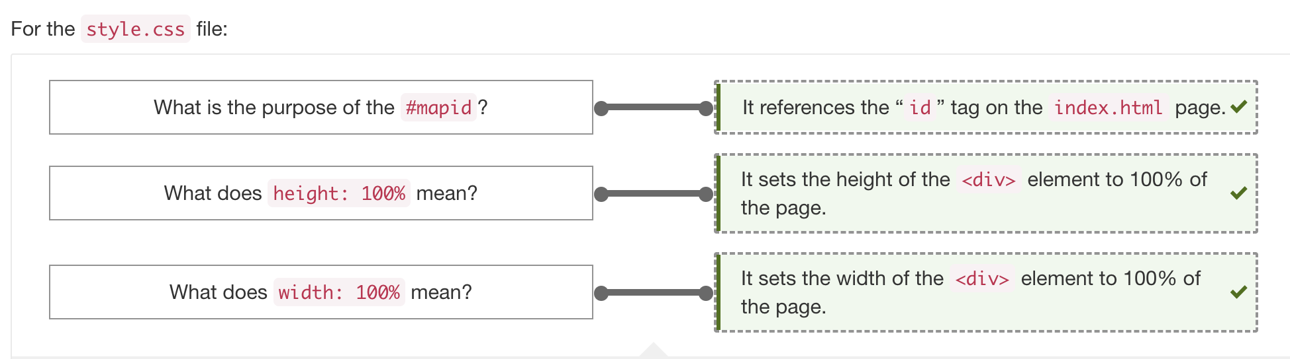

**Finally**, we need to tell our index.html page to use the style.css file we created…In the <head> section of our index.html page, add the following CSS link script below the Leaflet CSS and before the closing </head> element:

<!-- Our CSS -->

<link rel="stylesheet" type="text/css" href="static/css/style.css">

13.2.4 **Create a Simple Map**

…you have added stylesheet links to your HTML page and CSS file…add the last two files to create a **simple map**—the config.js file for your API token and the logic.js file for your JavaScript and Leaflet code.

## **Add the config.js File**

In our Simple_Map folder, add a new folder in the static folder called "js." In the js folder, create a new file and name it config.js. This file will hold our Mapbox API key.

(The config.js file is like the config.py file we used to hold the OpenWeatherMap API and Google API keys.)

On the first line of the config.js file, add the following code: // API key

const API_KEY = "";

## **Add the logic.js File**

Next, in the js folder, create a new file and name it, logic.js. Now we'll add some boilerplate code to the logic.js file. Most of this code can be reused for many of the maps we'll create later on in this module…On the first line, add the following code:

// Add console.log to check to see if our code is working.

console.log("working");

The console.log() function with the phrase "working" inside the parentheses will help us confirm that our logic.js file is being accessed in the console on Chrome.

## **Add a Map Object**

Next, we'll add the map object, as shown on the Leaflet Quick Start Guide page with some slight modifications. We'll change the geographical center of the map to the **approximate geographical center of the United States.**

// Create the map object with a center and zoom level

let map = L.map('mapid').setView([40.7, -94.5], 4);

1. We're assigning the variable map to the object L.map(), and we'll instantiate the object with the given string 'mapid'.
2. **The mapid will reference the id tag in our <div> element on the index.html file.**
3. The setView() method sets the view of the map with a geographical center, where the first coordinate is latitude (40.7) and the second is longitude (-94.5). **We set the zoom level of "4" on a scale 0–18**.

**An alternative**A to using the setView() method is to modify each attribute in the map object using the curly braces notation as follows:

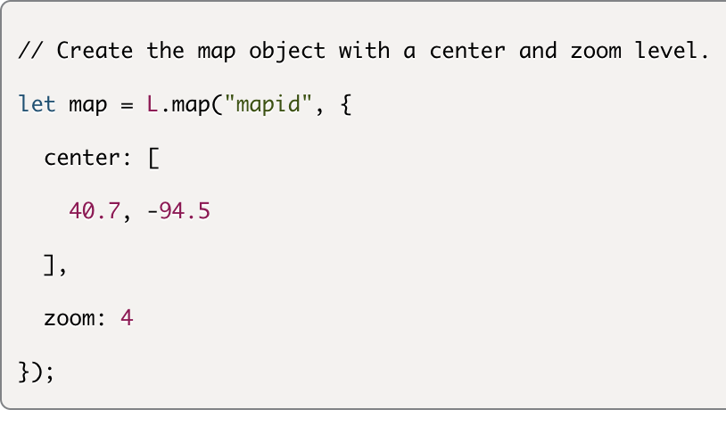

*** This method is useful when we need to add multiple tile layers, or a background image of our map(s), which we will do later in this module.

**Add a Tile Layer For Our Map**

Now, we will add the map tile layer method to the logic.js file. The tile layer is used to load and display a tile layer on the map. We have two options to create a tile layer.

#### **Use the Leaflet Documentation**

The [Leaflet Quick Start Guide (Links to an external site.)](https://leafletjs.com/examples/quick-start/)

(Doesn’t really provide) provides the tileLayer() code

We can copy this tile layer code and assign it to the streets variable, since the tile layer will create a street-level map. Add the following code block to your logic.js file:

// We create the tile layer that will be the background of our map.

let streets = L.tileLayer('https://api.mapbox.com/styles/v1/{id}/tiles/{z}/{x}/{y}?access_token={accessToken}', {

attribution: 'Map data &copy; <a href="https://www.openstreetmap.org/">OpenStreetMap</a> contributors, <a href="https://creativecommons.org/licenses/by-sa/2.0/">CC-BY-SA</a>, Imagery © <a href="https://www.mapbox.com/">Mapbox</a>',

maxZoom: 18,

id: 'mapbox/streets-v11',

tileSize: 512,

zoomOffset: -1,

accessToken: API_KEY

});

// Then we add our 'graymap' tile layer to the map.

streets.addTo(map);

Let's break down what's happening in this code block:

1. We assign the tileLayer() method, as shown in the Quick Start Guide's "Setting up the map" section to **the variable streets**. Leaflet doesn't provide a tile layer. Instead, it offers various tile layer APIs.
2. The following URLs appear in the parentheses of our tileLayer() method:
   * The API URL with a reference to the accessToken
   * The OpenStreetMap URL inside the curly braces of our tileLayer() method
3. We add the maxZoom attribute and assign it a value of 18.
4. We add the id attribute and assign it mapbox/streets-v11, which will **show the streets on the map**.
5. We add the **accessToken attribute and assign it the value of our API_KEY**.
6. Finally, we call the addTo() function with our map object, map on our graymap object tile layer. The addTo() function will add the graymap object tile function layer to our let map (from previous line of code .)

To change the map's style, change the map id using the list of Mapbox ids below:

* mapbox/streets-v11
* mapbox/outdoors-v11
* mapbox/light-v10
* mapbox/dark-v10
* mapbox/satellite-v9
* mapbox/satellite-streets-v11

#### **Use the Mapbox Styles API**

To use the Mapbox Styles API, edit the URL in the Leaflet tilelayer()method, as detailed on the Leaflet website:

1. First, navigate to the [Mapbox Glossary (Links to an external site.)](https://docs.mapbox.com/help/glossary/)
2. Search the [Static Tiles API (Links to an external site.)](https://docs.mapbox.com/help/glossary/static-tiles-api/)
3. Copy this part of the URL: https://api.mapbox.com/styles/v1/mapbox/streets-v11/.
4. In your tileLayer() code, replace this part of the URL, https://api.tiles.mapbox.com/v4/{id}/, with the Mapbox Styles API URL you copied.
5. Remove the .png from the URL.
6. Remove the id attribute and the map style reference. (id tileSize zoomOffset, prev added)
7. The code for the tileLayer() should look like the following: XXXX
8. To change your map style, click on the [Static Tiles API documentation (Links to an external site.)](https://docs.mapbox.com/api/maps/#static-tiles) link on the Static Tiles API page.
9. On the left sidebar, click on the [Styles (Links to an external site.)](https://docs.mapbox.com/api/maps/#styles) link.
10. Below the Styles subheading, find a list of different Mapbox styles.
11. To change the map style, use the style given in the URLs (e.g., "streets-v11," "dark-v10," etc.).

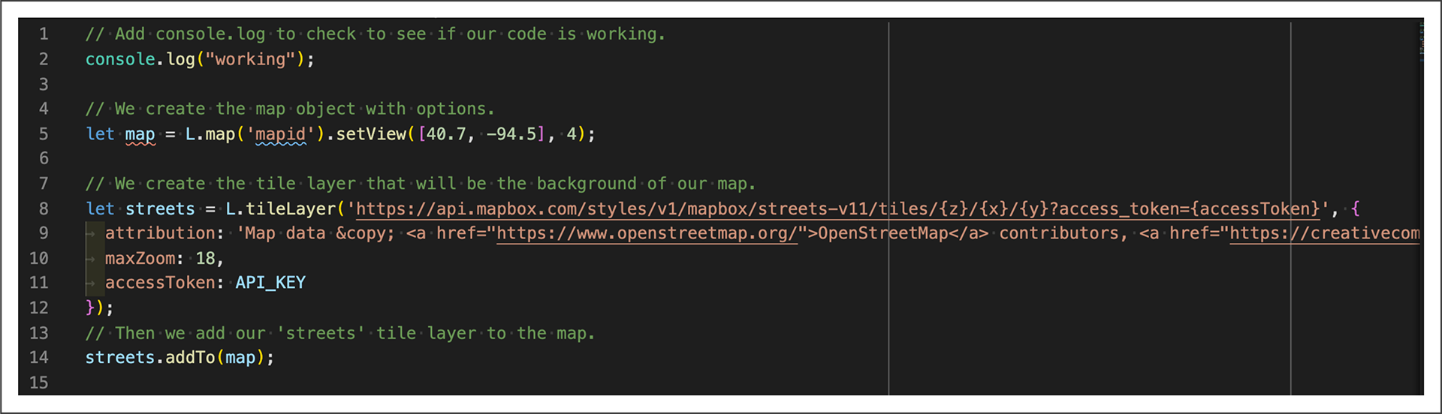

Next, we'll add the logic.js and config.js scripts to the HTML page

**Add JavaScript Tags to HTML Page**

To do this, open up the index.html file and add the following <script> elements below the Leaflet JavaScript link script and above the closing </body> element, and save the file.

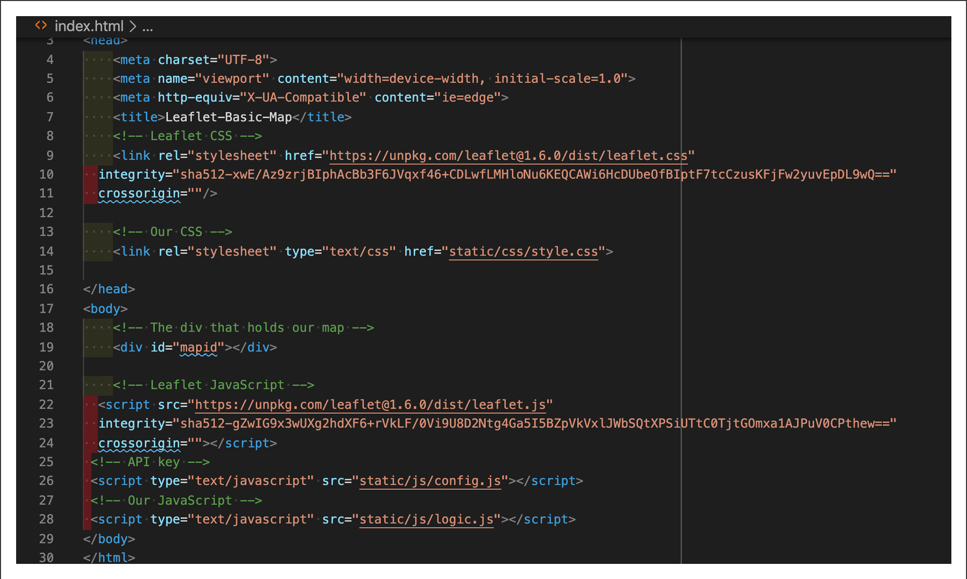

**Open the Map in the Browser** open the index.html file

To open the index.html file in the browser:

1. Open the command line and navigate to your Mapping_Earthquakes folder. The index.html file should be in the top-level of that folder.
2. On the command line, type python -m http.server and press Enter.

Or click on the index.html file in Finder

**13.3.1 Add, Commit, Push to a Branch**

commit your changes to the Simple_Leaflet_Map branch so the team can review…If there are no changes to be made to your branch, then you can merge it with the main branch

First, we'll check to see if you're in the Simple_Leaflet_Map branch. In the command line, navigate to your Mapping_Earthquakes folder and type git branch. If the following output is returned with an asterisk next to the branch name, you're in the Simple_Leaflet_Map branch

Just as we have checked the main branch status of other repositories, we'll do the same with the Simple_Leaflet_Map branch.

After typing git status, the command line should show the following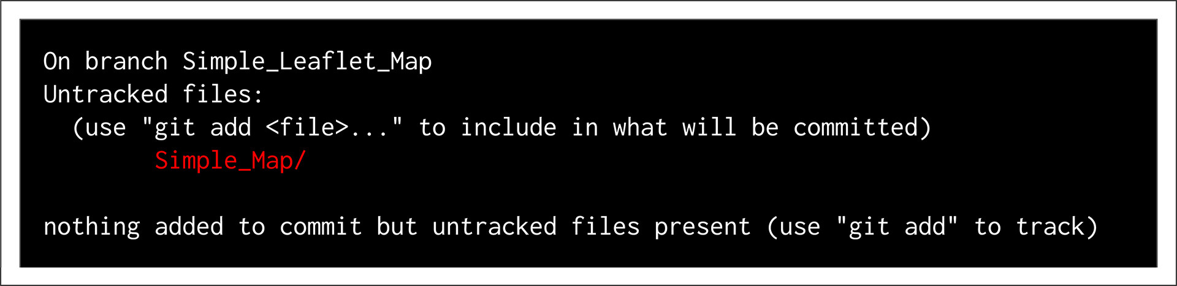

To see all the folders and files in the Simple_Map folder, type git status -u and press Enter. The output in the command line should look like the following: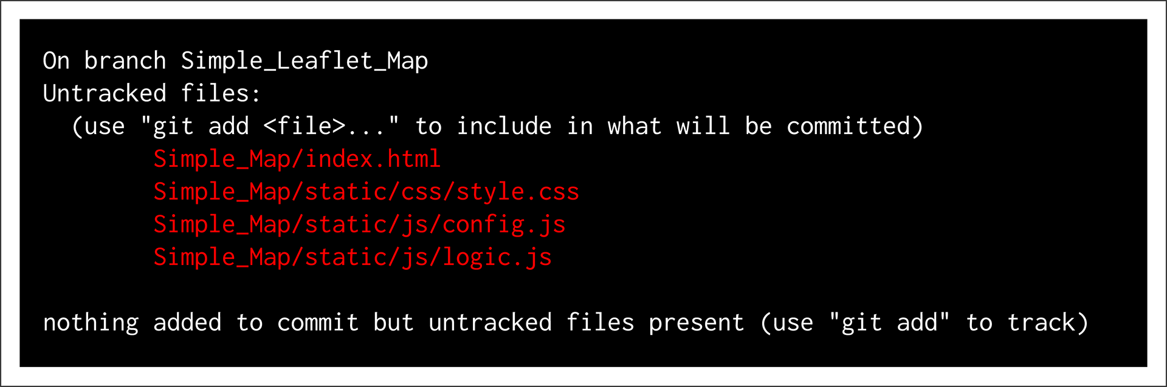

If you didn't initialize the repository with a .gitignore file, we'll create one. Then we'll add config.js to the .gitignore file so that GitHub doesn't track that file. In VS Code, create a new file in the Simple_Map folder and name it .gitignore. Your repository folder should look like the following: 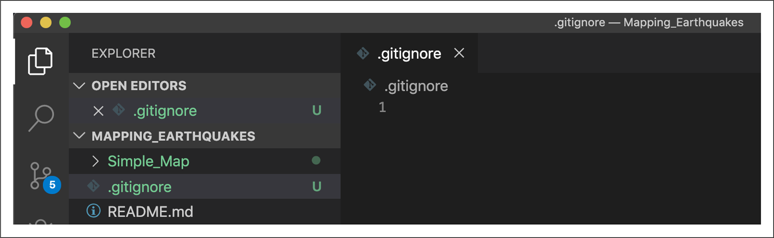

Next, add the following lines to the .gitignore file and save the file: # Ignore the config.js file.

Config.js

In the command line, type git status - u and press Enter. The output should have the .gitignore file and all the files as before, except the config.js file. All the files in red will be tracked when we use git add, with the exception of the config.js file.

**Nex**t, we'll add these folders and files to the Simple_Leaflet_Map branch as we did for the main branch.

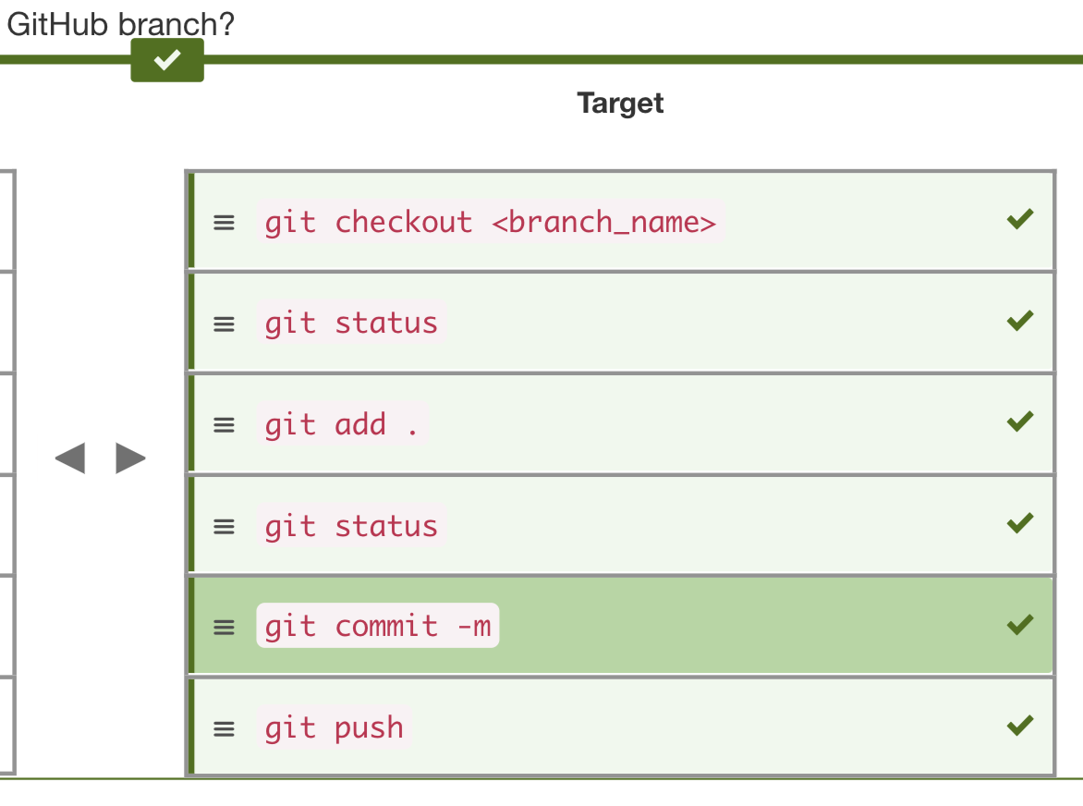

After typing git push and pressing Enter, the output message will look like the following:

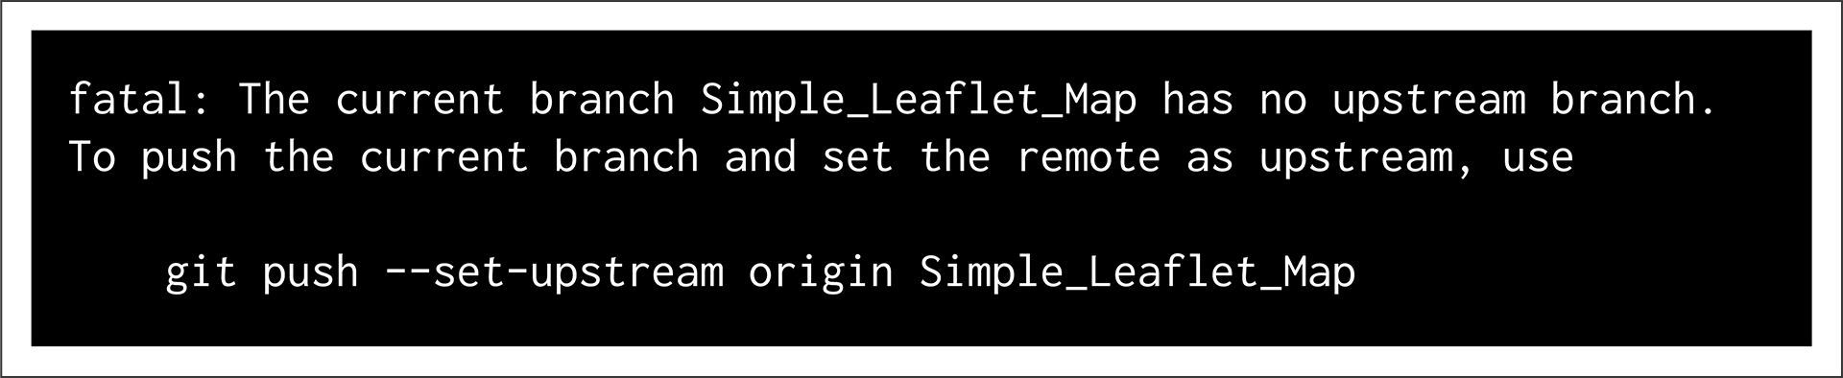

To push the folders and files to the Simple_Leaflet_Map branch for the first time, type git push --set-upstream origin Simple_Leaflet_Map in the command line and press Enter.

(To add any files after this initial push, type git push)

13.3.2 **Compare Branch to the main Branch**

To merge your Simple_Leaflet_Map branch with the main branch, we will:

1. Compare the changes between the Simple_Leaflet_Map branch and the main branch so that we can merge them.
2. If we are able to merge the Simple_Leaflet_Map branch into the main branch, we need to create a pull request on GitHub.
3. After we review the pull request, we can merge the branch into the main branch.

Let's compare the changes between our Simple_Leaflet_Map branch and the main branch:

1. Navigate to your Mapping_Earthquake GitHub repository.
2. To start merging your branch into the main branch, compare the branches to confirm they can be merged.
3. You have two ways to compare your branch with the main branch:

* Click the green "Compare & pull request" button, or
* Click the gray "New pull request" button.

(If you click the "Compare & pull request" button, skip to Step 5.)

5. Click on the "compare: **main**" button and select the branch you want to compare (the Simple_Leaflet_Map branch).

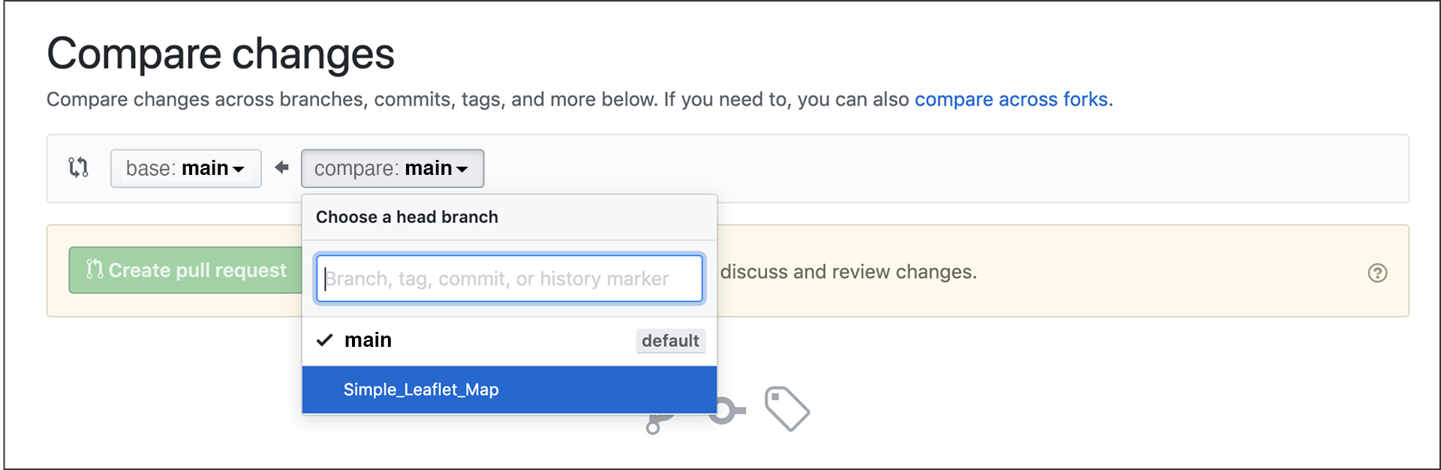

13.3.3 **Create a Pull Request**

First, select the Simple_Leaflet_Map branch.

Or, you can select the green "Compare & pull request" button.

A new page called "Open a pull request" will launch.

The page shows the five key elements of a pull request:

1. Near the top of the page is a green checkmark and text stating "Able to merge." If you're unable to merge, GitHub will display an explanatory message.
2. Next is the commit message you made.
3. "Reviewers" and "Assignees" are members, such as yourself, with access to the repository. You can assign the pull request to yourself. Labels, Projects, and Milestones are completed by team members and owners of the repository. Click on a gear wheel to modify any of these items.
4. In the "Leave a comment" field, describe what you're adding to the main branch in the pull request.
5. After entering a comment, click the green "Create pull request" button.

Scroll below "Open a pull request" to see the files you're adding to the pull request.

Write a message and create a pull request. In the "Leave a comment" field, type the following message:

XXX

After you click the green "Create pull request" button, the page should look similar to the following:

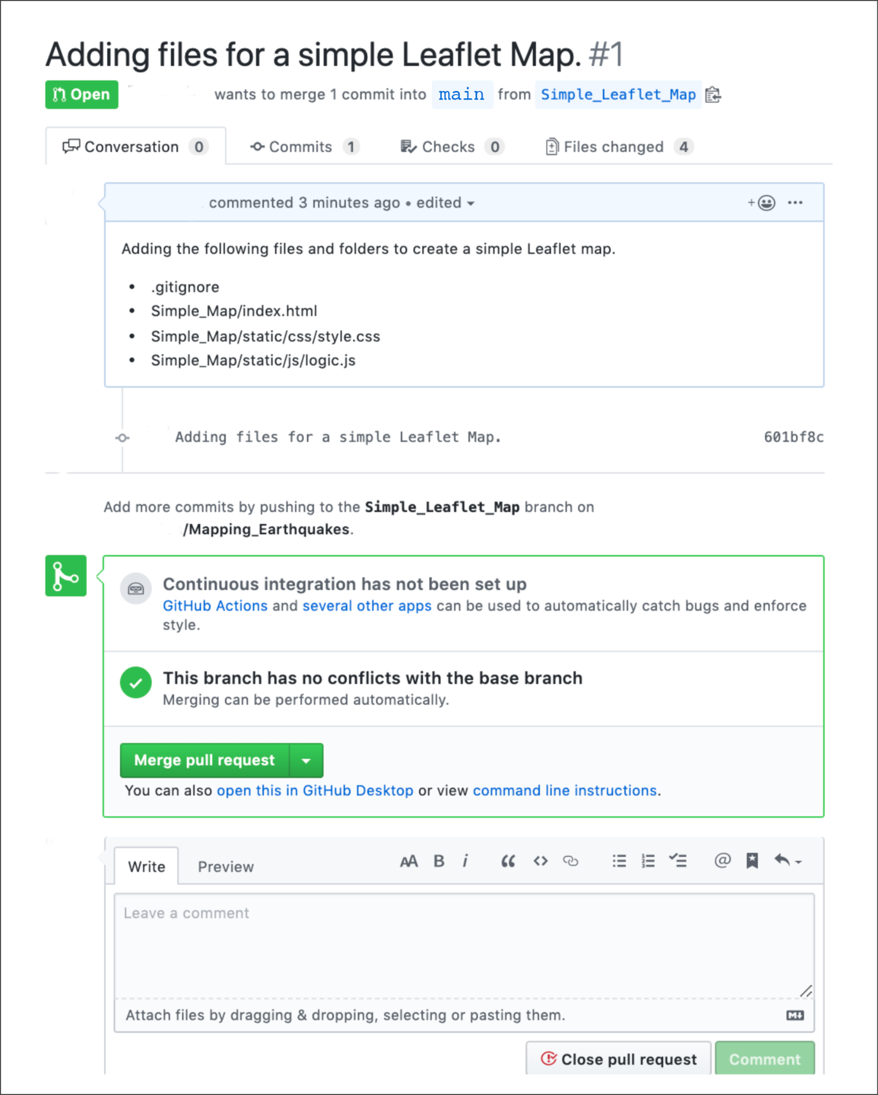 If your code looks good, click the "Merge pull request" button.

13.3.4 **Merge Branch Into main Branch**

creating a pull request, which can be daunting sometimes

After clicking the "Merge pull request" button, the page will refresh with two options: "Confirm merge" or "Cancel."

Click the green "Confirm merge" button. The page refreshes to confirm, in three places, that the pull request has been merged into the main branch.

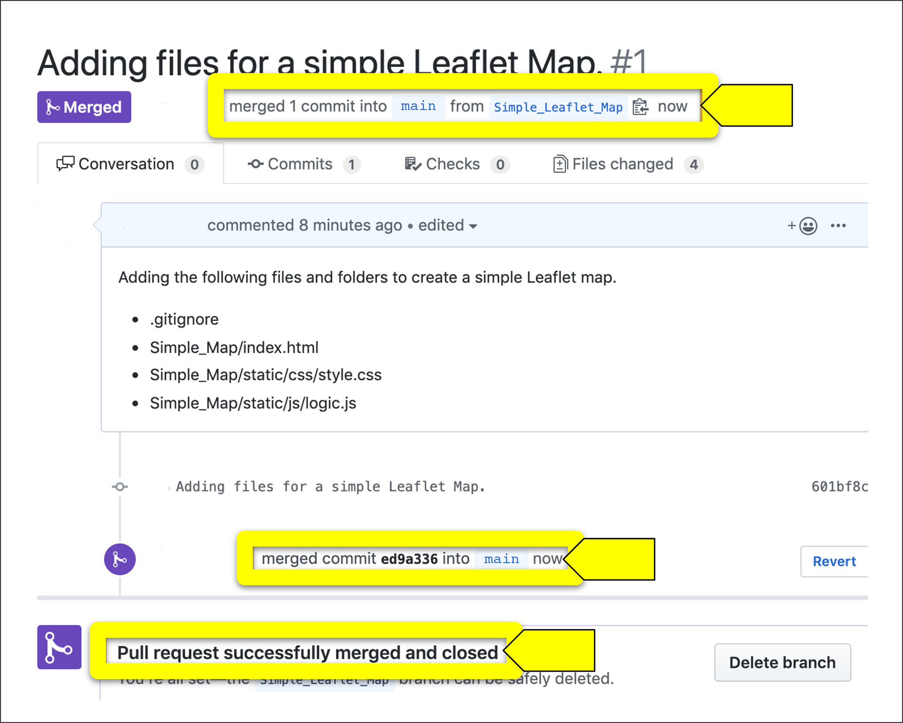 Navigate to the main branch on GitHub to confirm all the folders and files have been merged from the Simple_Leaflet_Map branch.

Next, pull the latest changes on the main branch on our computer because the main branch on our computer is not up to date. Follow these steps.

1. Open the terminal or Git Bash and type git checkout main and press Enter.
2. Type git status and press Enter. The output might tell you that you are up to date, which can be misleading, or it might say you are "1" commit behind the Simple_Leaflet_Map branch.
3. Type git pull and press Enter. The output should look like the following: 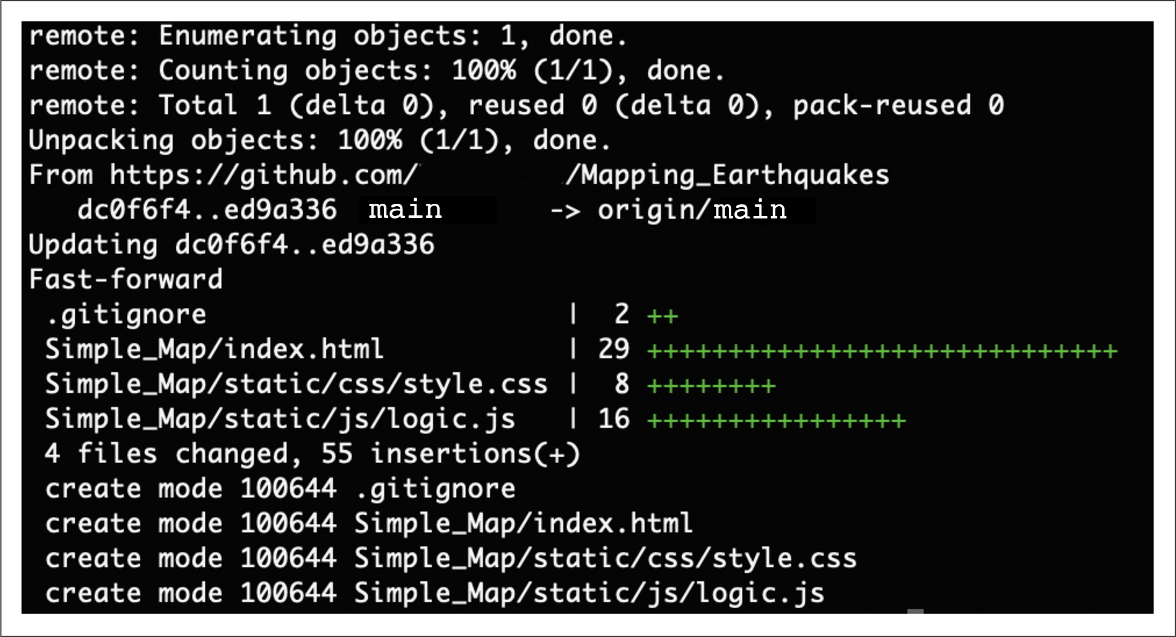
4. To confirm that the files are in the main branch on your computer, if you have a Mac type open . to view the directory in Finder, or if you have a PC type start . to view the directory in File Explorer.

13.4.1 **Map a Single Point**

Creating a simple Leaflet map was relatively straightforward. Now, add a single marker to a map and change the radius of the marker… but create a branch for adding points to a map for the GitHub repository so that new interns and employees can use this as a tutorial.

Follow these steps to create a branch off of the main branch:

1. Navigate to your repository on your computer.
2. Make sure you're on the main branch by typing: git branch
3. If you're not on the main branch, type: git checkout main
4. Pull the changes from the main branch by typing: git pull
5. Create a new branch by typing: git checkout -b [name_of_your_new_branch]

The two files that we'll change most often are the index.html and the logic.js files. Also, we might add an external file in the js folder. After checking out the new Mapping_Single_Points branch, copy all files from your Simple_Leaflet_Map folder and add them to a new Mapping_Single_Points folder..

Next, push the latest changes to the Mapping_Single_Points branch to GitHub.

Follow these steps to push changes to a new branch:

1. Type: git status
2. Add the folders and files by typing: git add .
3. Confirm the correct files will be added by typing: git status
4. Commit the changes by typing: git commit -m
5. Push the changes to the branch by typing: git push --set-upstream origin Mapping_Single_Points

After adding the folders and files to your Mapping_Single_Points branch, your repository should look like the following: 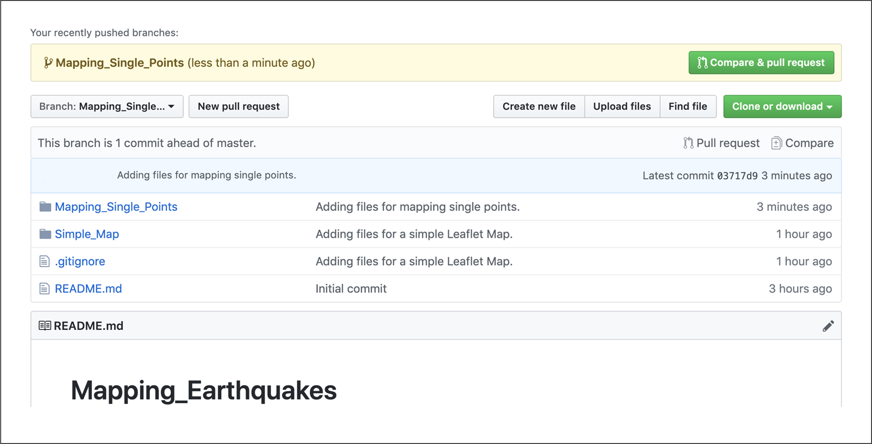

**Next**, we'll edit the logic.js file to add single points or markers to the basic map.

## **Add a Marker to the Map**

Adding a marker to our simple map requires only one line of code, found in the [Leaflet Quick Start Guide (Links to an external site.)](https://leafletjs.com/examples/quick-start/)

, under the "Markers, circles and polygons" subheading. Below the map is a line of code that reads as follows:

var marker = L.marker([51.5, -0.09]).addTo(map);

We're going to edit this line of code with the latitude and longitude for Los Angeles, California, and add it to our logic.js file that we used to create a simple map.

Open up the logic.js file using VS Code and add the following line of code before our tileLayer()code, and save the logic.js file:

// Add a marker to the map for Los Angeles, California.

let marker = L.marker([34.0522, -118.2437]).addTo(map);

Next, open the index.html file in your browser. Your map should look like the following: 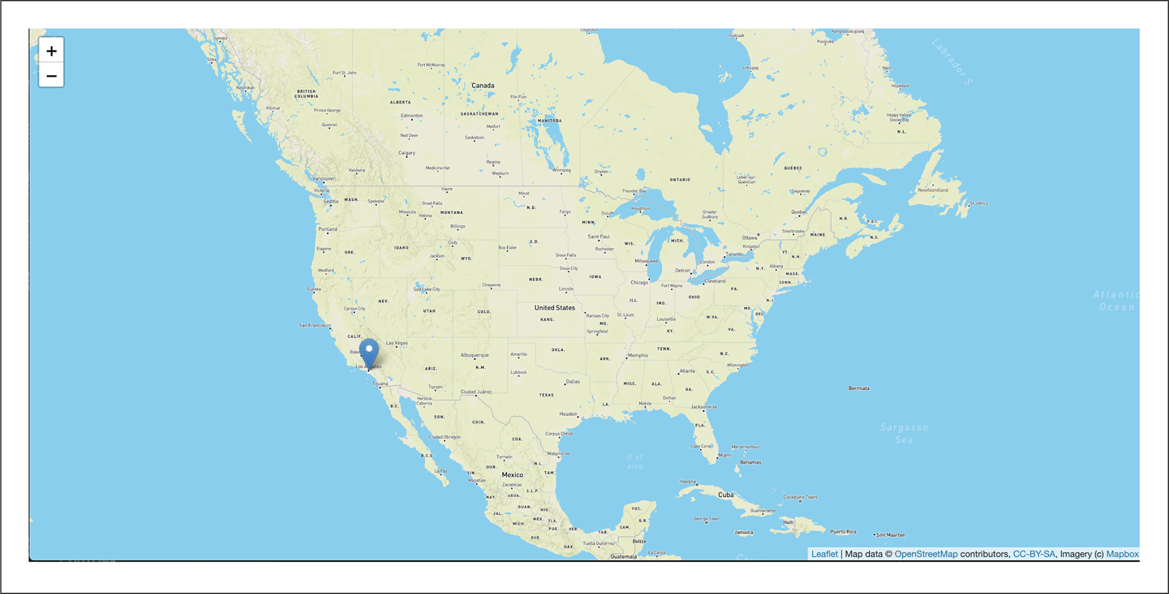Next, we'll change the marker to a circle.

## **Add a Circle to the Map**

To change the marker on our map to a point or dot, we'll use the circle() function. The circle() function will place a circle on the map at the given coordinates. The syntax for using the circle() function is as follows:

L.circle([34.0522, -118.2437], {

radius: 100

}).addTo(map);

The radius for the circle() function is measured in meters. For the code above, add a circle with a 100-meter radius over Central Los Angeles when we assign a value to the radius key in the circle() function. Copy the code for the circle function and replace the marker()with it (we used previously). We're also going to zoom in to a level of 14 on the setView() method. After editing your logic.js file, it should look like the following:

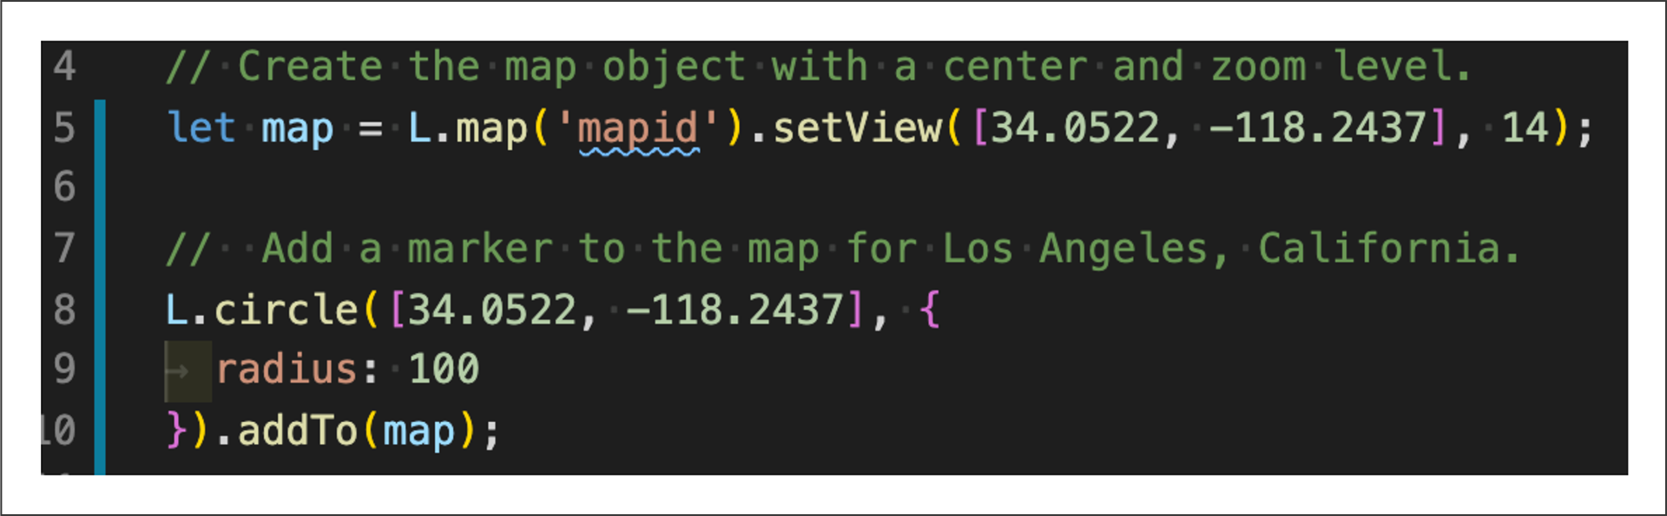

Alternatively, we can create a circle using the circleMarker() function. The circleMarker() function measures the radius of the circle in pixels, with the default radius set at 10 pixels. The syntax for using the circleMarker() function follows: L.circleMarker([34.0522, -118.2437]).addTo(map);

Let's create a light-yellow circle with black lines indicating a 300-pixel/300-meter radius on a dark map. Edit your logic.js file from the previous Skill Drill by changing your circle()function to a circleMarker()function. Your logic.js file should now look like the following: 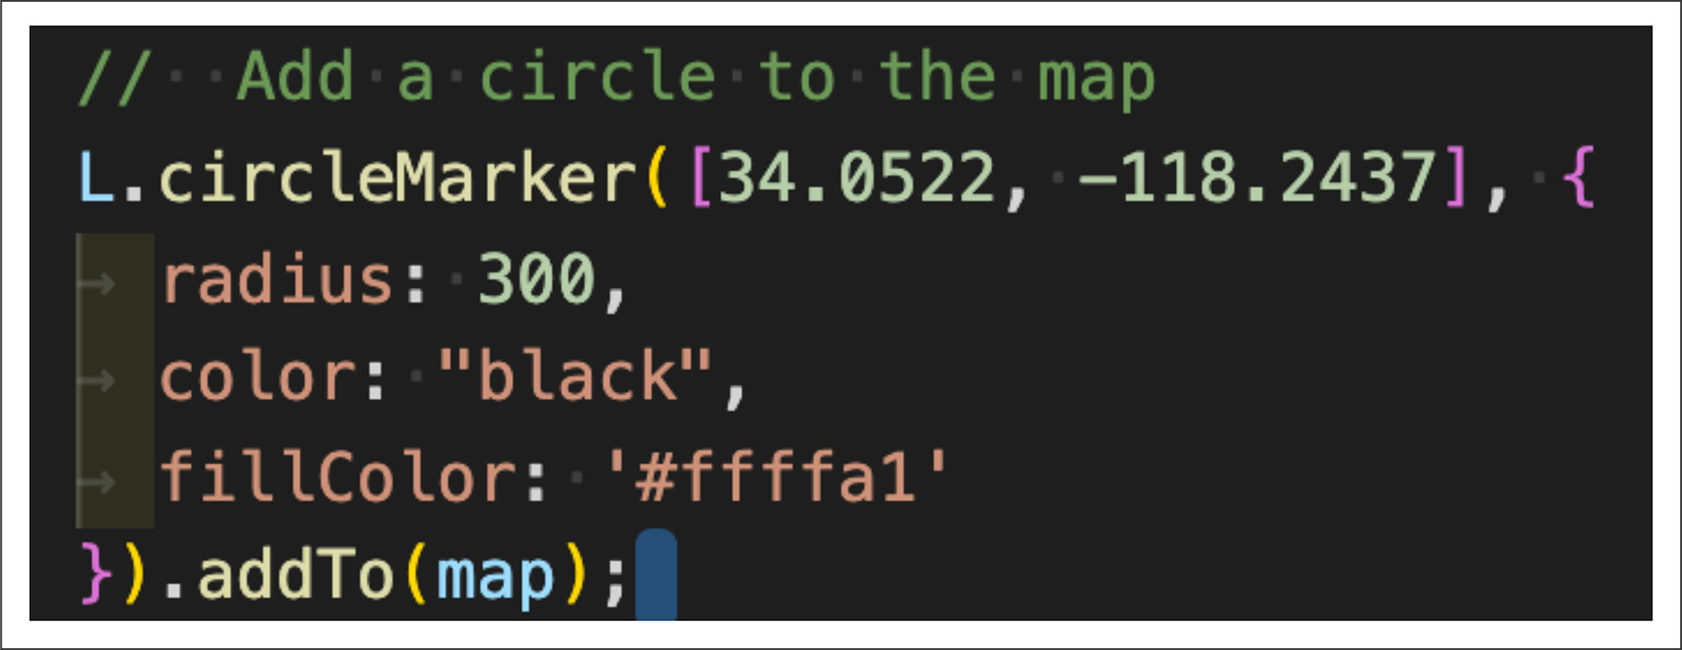 If you didn't get the correct map style in the Skill Drill, replace the "streets-v11" in our tileLayer() code with "dark-v10"

**Random:**

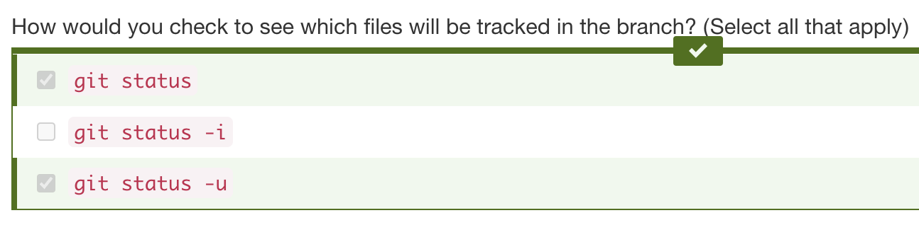

**Next** - going to show you how to add multiple locations to a map and change the radius of each marker.

Use the links below to learn more about these Leaflet functions:

* [marker() function (Links to an external site.)](https://leafletjs.com/SlavaUkraini/reference-1.6.0.html#marker)
* [circle() function (Links to an external site.)](https://leafletjs.com/SlavaUkraini/reference-1.6.0.html#circle)
* [circleMaker() function](https://leafletjs.com/reference-1.6.0.html#circlemarker)

13.4.2 **Map Multiple Points**

iterate through an array of objects and map them… create a new branch for adding multiple points to a map.

create a new branch for mapping multiple points…Create a new branch called "Mapping_Multiple_Points"

* Merge in GitHub
* Do “git pull” in Terminal

## **Add Multiple Markers**

When we added a single marker to our simple map, we assigned our marker variable to the Leaflet class marker() function. This function will only add one latitude and longitude to the map. To add more markers to the map, the latitudes and longitudes are usually nested in an array. To add a marker for each location, we have to iterate through the array and add each latitude and longitude to the map.

Next, we need to iterate through each city object and add each city location to the marker() function, which will, in turn, be added to the map.

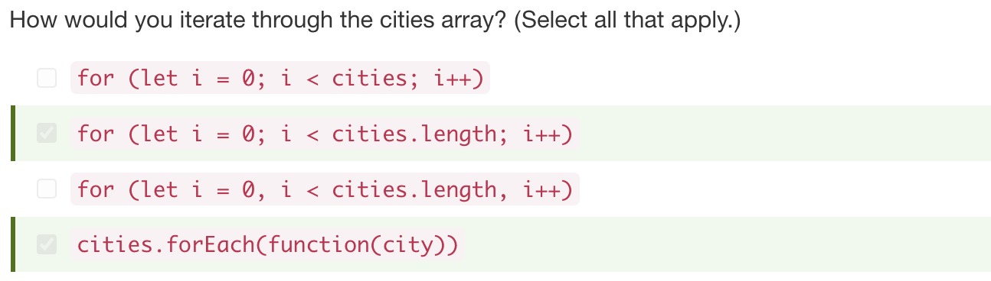

Below the cities array, add the following code to iterate through the array. Inside the brackets, use the console.log() function to print each object in the array to the console:

// Loop through the cities array and create one marker for each city.

cities.forEach(function(city) {

console.log(city)

});

Save the logic.js file and open the index.html file in your browser.

If we look at the console tab, we'll see that each object, or city, of the cities array is printed to the console.

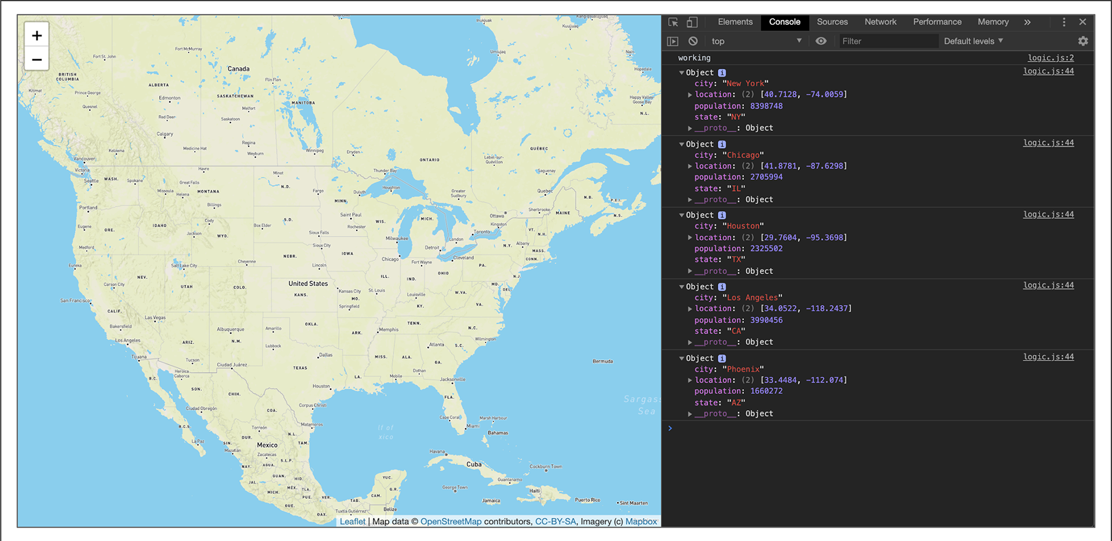

Now, add each city's location to the map by adding the location to the marker() function.

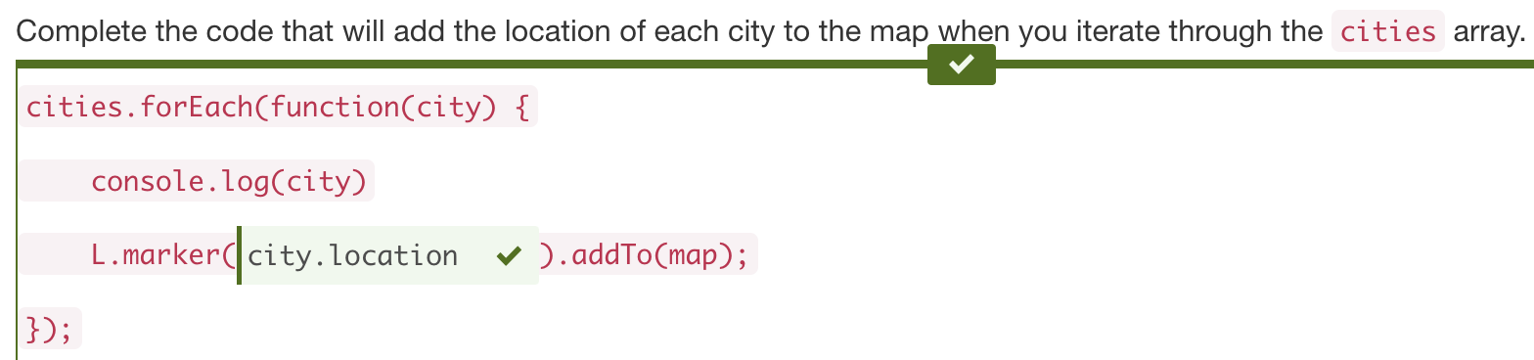

* The City and Location from the array

In the forEach() function, assign the city variable to each object of the cities array (cities.js file ??). Then, get the coordinates of each city by adding city.location in the L.marker() function. We can then add each location to the map with the addTo() function and pass the map object as the argument. Add/update the following code to your logic.js file and save it:

// Loop through the cities array and create one marker for each city.

cities.forEach(function(city) {

console.log(city)

L.marker(city.location).addTo(map);

});

When you open the index.html file in your browser, the map will show a marker on each city in the cities array. 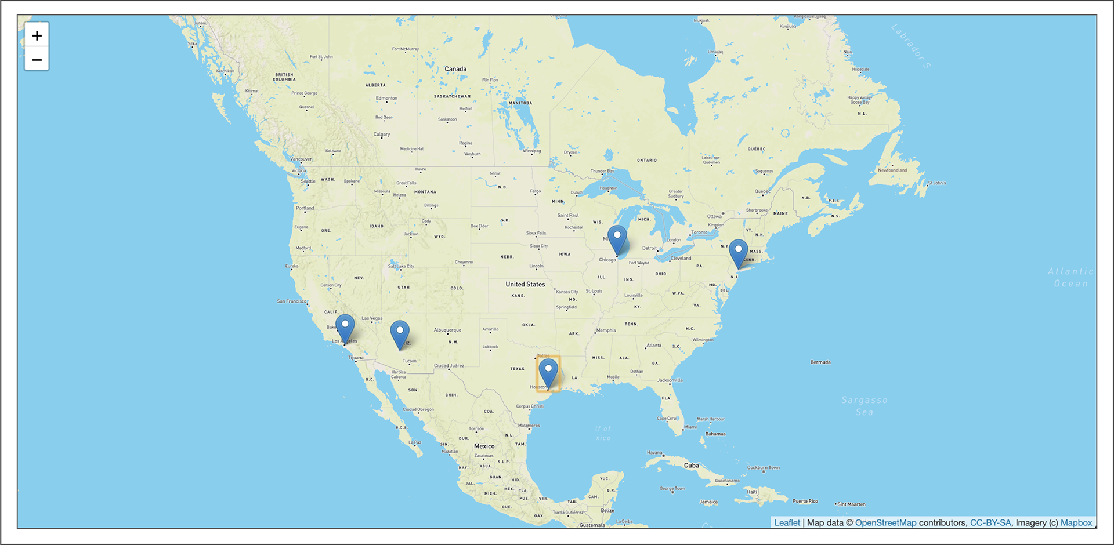

When handling large datasets, it's a best practice to have the data in an external file and refer to that file and dataset in the logic.js file.

Even though our cities array is not that large, let's create a new file in the "js" folder called cities.js. Cut the cities array data from the logic.js file, place it in the cities.js file, and save the file.

Next, in the logic.js file, where the cities array was located, add a variable and assign it to the cities array. Add the following code to the logic.js file:

// Get data from cities.js

let cityData = cities;

Next, in the body of the index.html file and before the path to the logic.js script, add a <script> file with the path to the JavaScript cities.js file, like this:

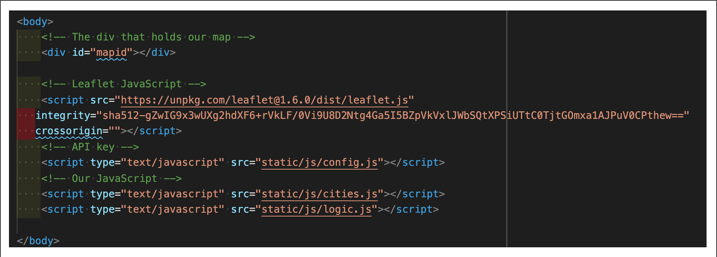

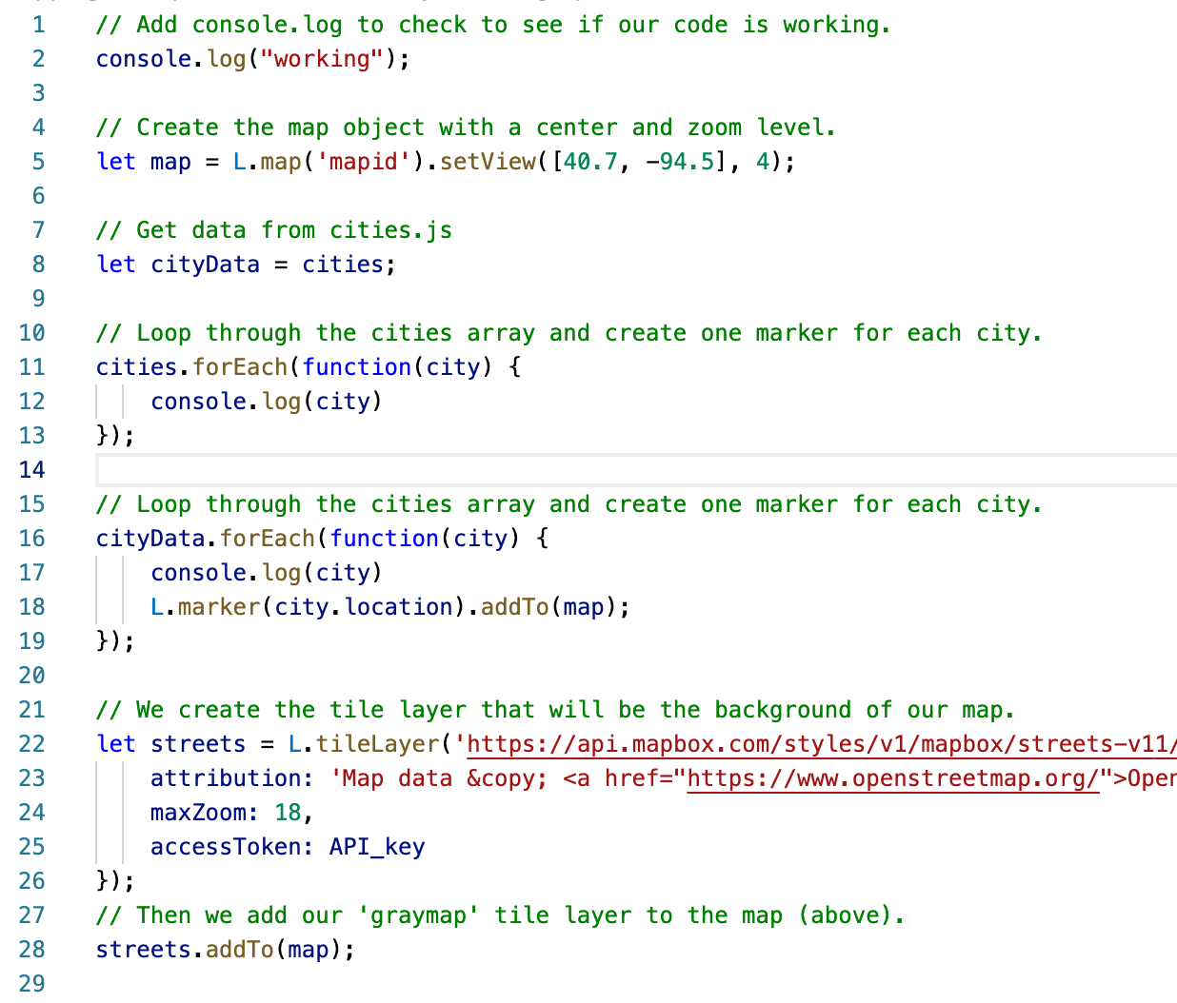

## **Bind a Popup to the Marker**

To add data from each object in the cities array, we'll use Leaflet's bindPopup() method on the marker() function. According to the guidance in the [Quick Start Guide (Links to an external site.)](https://leafletjs.com/examples/quick-start/)

's "Working with popups" section, we only need to add HTML code inside the parentheses of the bindPopup() method:

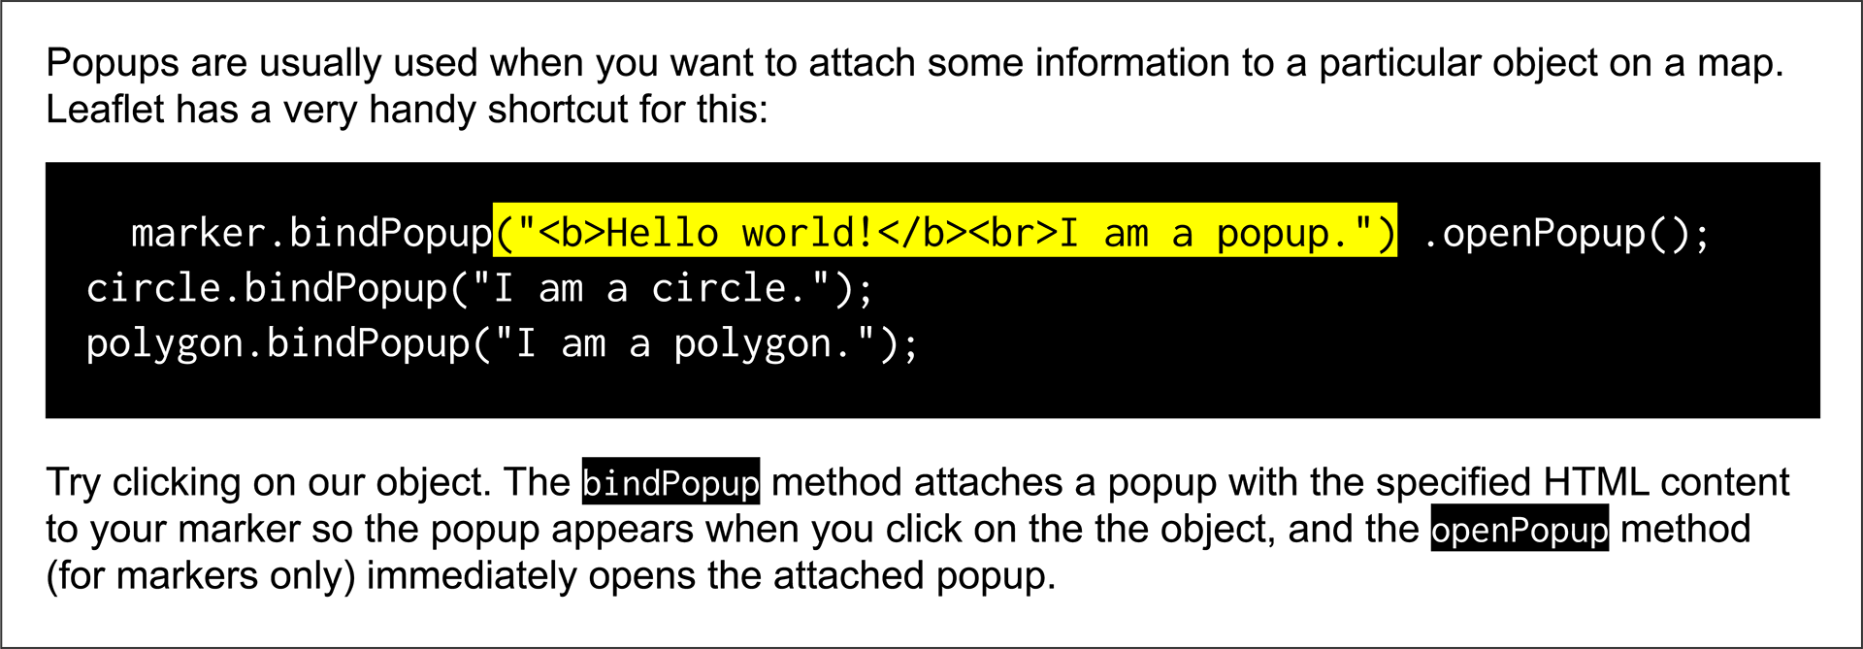

In the logic.js file, edit the forEach function and add the bindPopup() method. Inside the parentheses of the bindPopup() method, we'll retrieve the name of the city, state, and population.

Edit the forEach function to look like the following, save the logic.js file, and open the index.html file in your browser:

// Loop through the cities array and create one marker for each city.

cityData.forEach(function(city) {

console.log(city)

L.marker(city.location)

.bindPopup("<h2>" + city.city + ", " + city.state + "</h2> <hr> <h3>Population " + city.population + "</h3>")

.addTo(map);

});

Now, when we click on each marker, it will show the name, state, and population of the city.

Let's format the population with a thousands separator by using the toLocaleString() method on the city.population in the bindPopup() method, like this:

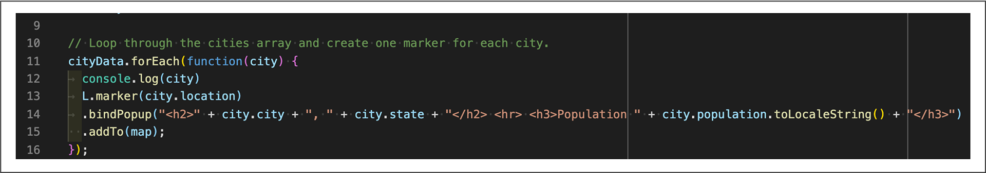

Now our popup markers have the population formatted with a thousands separator.

Next, change the marker for each city to a circle that has a radius equivalent to the city's population.

In the logic.jsfile, we'll replace the marker() function with the circleMarker() function in the forEach() function. Then we'll assign the "radius" key to the population by using city.population.

The forEach() function in our logic.js file should look like the following:

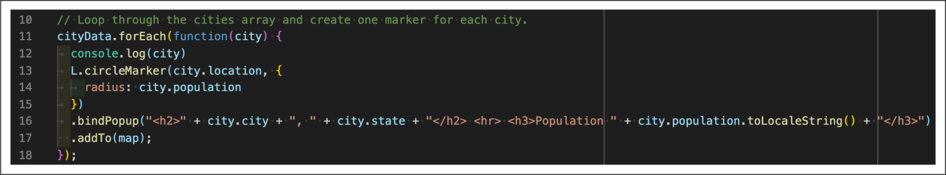

After you save the logic.js file and open the index.html file in your browser, your map will look like the following:

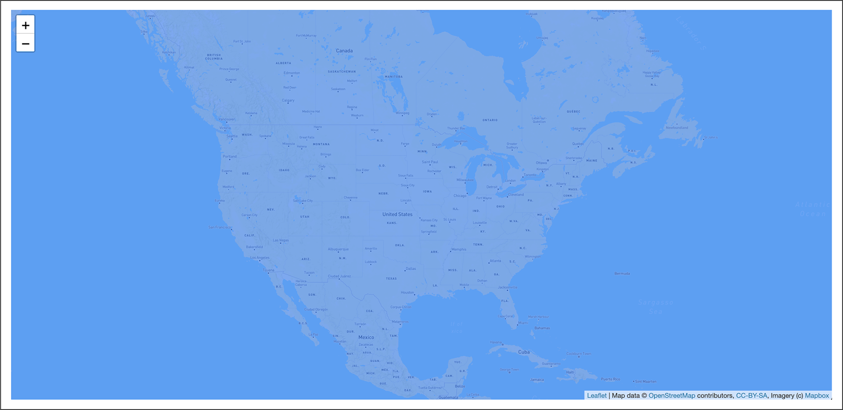 The radii are too large.

To fix this, we'll have to decrease each city's radius so the circle markers fit on the map. In the logic.js file, divide the city.population value by "100000" to look like this: radius: city.population/100000

13.4.3 **Map Lines**

**Map a single line**

Adding lines to a map requires that the coordinates for the starting and ending points be a one-dimensional array with two elements: latitude and longitude. To illustrate how lines are mapped, let's map the airline route from Los Angeles to San Francisco. Mapping airline routes will help us understand how tectonic plate data is added to a map.

The starting point for our line will be the **Los Angeles International Airport (LAX)**, with the coordinates [33.9416, -118.4085]. The ending point for our line will be the **San Francisco International Airport (SFO)**, with the coordinates [37.6213, -122.3790].

When we create a line in Leaflet, the starting and ending points and all coordinates along the route need to be in an array. We can assign the array to the line variable like this:

// Coordinates for each point to be used in the line.

let line = [

[33.9416, -118.4085],

[37.6213, -122.3790]

];

Let's edit our logic.js file to create a line from LAX to SFO.

* First, change the coordinates for the center of the map to somewhere between LAX and SFO by adding [36.1733, -120.1794] in the setView() method.
* Change the zoom level in the setView() method to 7.
* Add the code for our line variable (as seen in the previous code snippet) below the map variable for the center of the map.
* Lastly, create a line on a map using the Leaflet polyline() function. Add the following line of code after the line variable:

In the polyline() function, we pass the line coordinates and the key-value pair color: "red" to make the line red.

Save the logic.js file with the changes. It should look like the following:

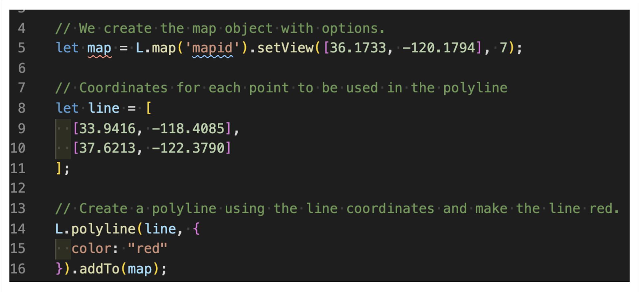

When you open the index.html file in your browser, your map should have a red line between LAX and SFO.

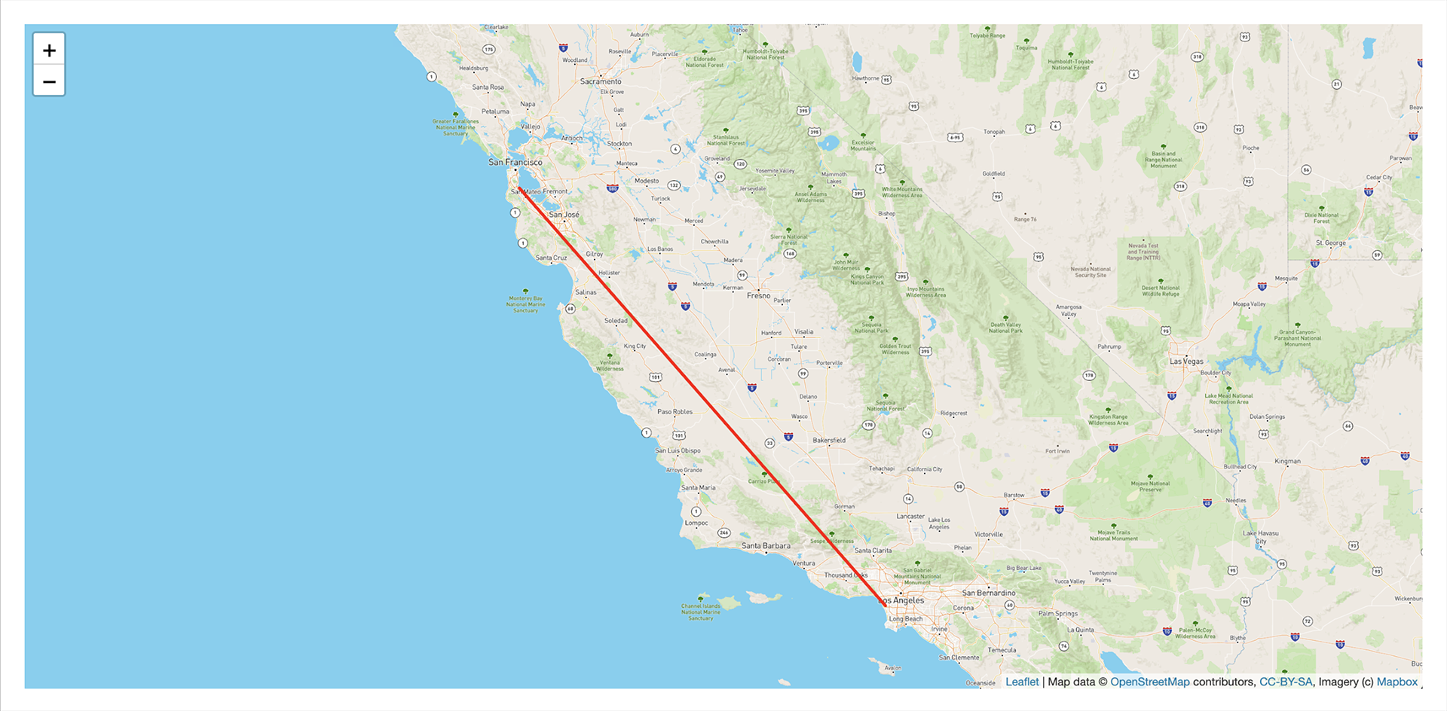

Now we'll add a few more stops on our airline route

**Map Multiple Lines**

Let's edit the logic.js file and add two more airport stops to our line variable: **Salt Lake City International Airport (SLC**) and **Seattle-Tacoma International Airport (SEA)**. Follow these steps:

1. Edit the line variable in the logic.js file so that it includes the two new sets of coordinates.
2. Make the line yellow by editing the value for the "color" key in the polyline() function to yellow.
3. Change the map style to "satellite-streets-v11."
4. Finally, change the center of the map to SFO and change the zoom to 5 so that we can see the line.

13.6.1

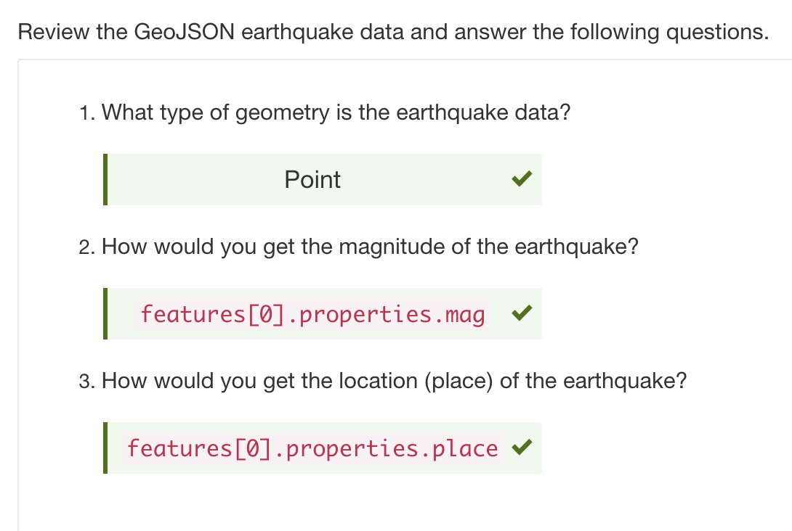

13.6.3

the size of the earthquake data based on magnitude looks great, but it's hard to tell the difference between earthquakes within the same area

13.6.4

The base layers or tile layers, the Streets and Satellite, are mutually exclusive, and only one can be visible at a time on our map. Whereas, overlays are anything that you want to add to the map, which are "laid over" all the base layers and are visible all the time.